SIMATS ENGINEERING
ASSESSMENT TOOL 1

COURSE NAME: Database Management Systems
COURSE CODE: CSA0509

COURSE OUTCOME COVERED

CO4: Design database solutions incorporating file organization, indexing, and hashing techniques to optimize data storage and retrieval efficiency. (BL3, BL4)

Activity Tool : Code Challenge (High)
Assessment Tool Weightage: 35%

QUESTIONS Total Marks: 50
Q.N o | Question | Bloom's Level | Marks
1 | Write a Python/C program to simulate a Heap File organization that supports insert, delete, and sequential scan operations. | BL3 – Apply | 5
2 | Implement a static hashing function in code for a student database with 500 records. Handle collisions using chaining. | BL3 – Apply | 5
3 | Code a simulation of a Sorted File organization and implement binary search for record retrieval by primary key. | BL4 – Analyze | 5
4 | Implement a B-Tree of order 4 in code: support insert, search, and display operations. Insert keys: 10, 20, 5, 6, 12, 30, 7, 17. | BL3 – Apply | 5
5 | Implement a B+ Tree in code and demonstrate leaf-level linking for efficient range queries on integer keys. | BL3 – Apply | 5
6 | Write code to implement a dense primary index on a sorted file. Support search by index key and display the index table. | BL4 – Analyze | 5
7 | Implement extendible hashing in code. Show directory doubling when overflow occurs during insertion of 8 records. | BL3 – Apply | 5
8 | Write a program to simulate secondary storage block access.  Calculate the number of I/O operations for sequential vs. indexed retrieval. | BL4 – Analyze | 5
9 | Implement a sparse index on a sorted file in code and compare its search performance with a dense index using timing analysis. | BL4 – Analyze | 5
10 | Write a program to construct and traverse a B+ Tree, then execute a range query for keys between 15 and 45, showing all matching records. | BL4 – Analyze | 5

Code of Conduct:

I JEROLD SAMUEL J (192571052)(Name / Reg No) certify that this submission is my original work and that I have adhered to the guidelines specified for this assessment.
I understand that any violation of academic integrity rules will result in disciplinary action.

Signature of the student: JEROLD SAMUEL J

RUBRICS FOR CALCULATION:

Criteria | Weightag  e | Level 4 (Exemplary) | Level 3 (Proficient) | Level 2 (Developing) | Level 1 (Beginning)
Problem Understanding | 20% | Clearly understands problem  constraints,  edge cases,  and competitive requirements | Understands problem with  minor gaps in constraints | Partial understanding; misses key constraints | Misinterprets problem or constraints
Algorithm | 25% | Selects optimal algorithm with  best time and space  complexity for competitive constraints | Uses efficient algorithm with  minor scope  for  improvement | Uses  basic/inefficien t approach | No clear algorithmic approach
Code  Implementatio n | 20% | Writes correct, efficient, and  clean code that passes all constraints | Code works with minor errors or inefficiencies | Partially correct code;  fails for some cases | Code does not execute or gives  incorrect results
Competitive Performance | 20% | Solves problem within time limits and  handles large inputs effectively | Solves within acceptable time with minor delays | Struggles with time limits or larger inputs | Unable to solve within time  constraints
Test Case Handling | 15% | Handles all test cases including edge and hidden cases | Handles most test cases | Misses important edge cases | Fails on multiple test cases

1. Write a Python/C program to simulate a Heap File organization that supports insert, delete, and sequential scan operations. Operations: Insert, Delete, Sequential Scan.
class HeapFile: def __init__(self): self.records = []

def insert(self, record):
self.records.append(record) print("Inserted:", record)

def delete(self, key): for i, record in enumerate(self.records): if record["id"] == key:
deleted = self.records.pop(i) print("Deleted:", deleted) return
print("Record not found")

def sequential_scan(self):
print("\nSequential Scan:") if not self.records:
print("Heap file is empty") return

for record in self.records:
print(record)

# Test heap = HeapFile() heap.insert({"id": 101, "name": "Arun"}) heap.insert({"id": 102, "name": "Bala"}) heap.insert({"id": 103, "name": "Charan"}) heap.insert({"id": 104, "name": "Divya"})

heap.sequential_scan()

heap.delete(102)

heap.sequential_scan()
Expected Output
Inserted: {'id': 101, 'name': 'Arun'}
Inserted: {'id': 102, 'name': 'Bala'}
Inserted: {'id': 103, 'name': 'Charan'}
Inserted: {'id': 104, 'name': 'Divya'}

Sequential Scan:
{'id': 101, 'name': 'Arun'}
{'id': 102, 'name': 'Bala'}
{'id': 103, 'name': 'Charan'}
{'id': 104, 'name': 'Divya'}

Deleted: {'id': 102, 'name': 'Bala'}

Sequential Scan:
{'id': 101, 'name': 'Arun'}
{'id': 103, 'name': 'Charan'}
{'id': 104, 'name': 'Divya'} Complexity:
- Insert: O(1)
- Delete: O(n)
- Sequential scan: O(n)
OUTPUT:
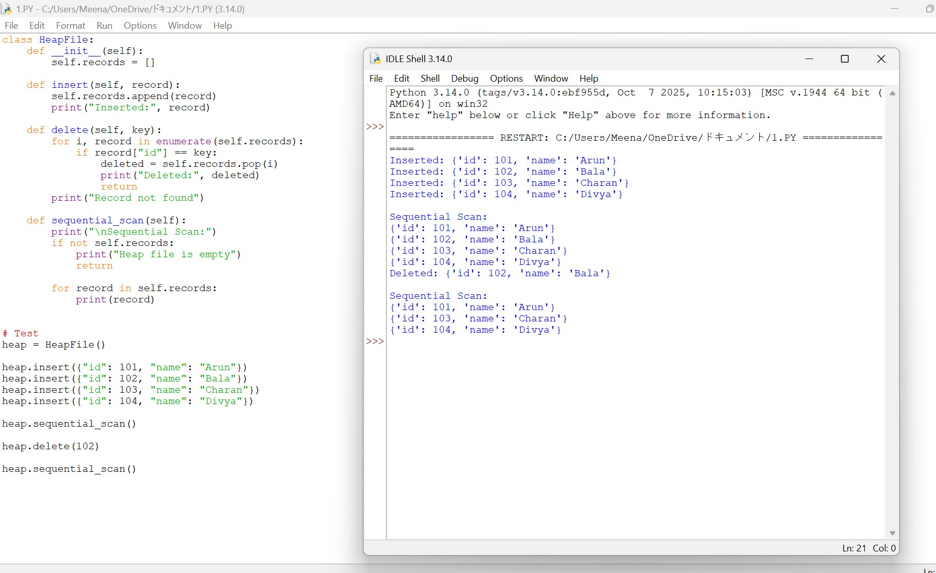

2. Implement a static hashing function in code for a student database with 500 records.
Handle collisions using chaining.
For 500 student records, the hash table uses chaining to handle collisions.
TABLE_SIZE = 503

class StaticHash: def __init__(self):
self.table = [[] for _ in range(TABLE_SIZE)]

def hash_function(self, student_id): return student_id % TABLE_SIZE

def insert(self, student_id, name):
index = self.hash_function(student_id)

for record in self.table[index]: if record[0] == student_id:
print("Duplicate Student ID:", student_id) return

self.table[index].append((student_id, name))

def search(self, student_id):
index = self.hash_function(student_id)

for record in self.table[index]: if record[0] == student_id:
return record

return None

def display_bucket(self, student_id): index = self.hash_function(student_id) print("Bucket", index, ":", self.table[index])

# Test with 500 records hash_table = StaticHash()

for i in range(1, 501):
hash_table.insert(1000 + i, "Student" + str(i))

# Collision demonstration hash_table.insert(1503, "CollisionStudent")

hash_table.display_bucket(1001) hash_table.display_bucket(1503)

print("Search Result:", hash_table.search(1250))
Key Features
- Table size: 503
- Records: 500
- Hash function: h(key) = key MOD 503
- Collision handling: Chaining Average complexity:
- Insert: O(1)
- Search: O(1)
- Worst case: O(n)

OUTPUT:
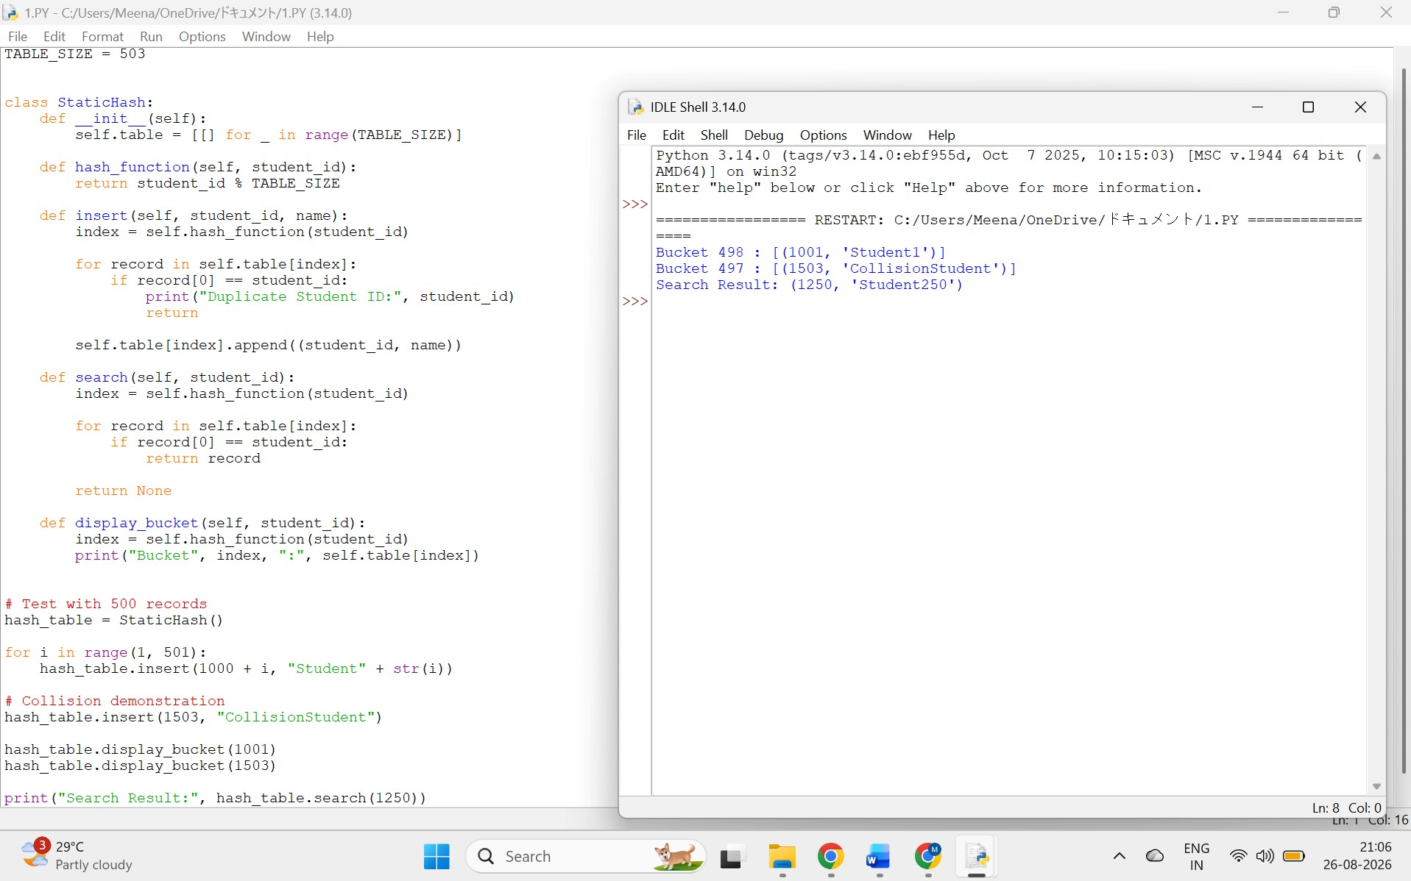

3. Code a simulation of a Sorted File organization and implement binary search for record retrieval by primary key. class SortedFile: def __init__(self): self.records = []

def insert(self, key, name):
self.records.append((key, name)) self.records.sort(key=lambda x: x[0])

def binary_search(self, key): low = 0
high = len(self.records) - 1

while low <= high:
mid = (low + high) // 2

if self.records[mid][0] == key:
return self.records[mid]

elif self.records[mid][0] < key:
low = mid + 1
else:
high = mid - 1

return None

def display(self):
print("Sorted File:") for record in self.records:
print(record)

# Test file = SortedFile()

file.insert(104, "Divya") file.insert(101, "Arun") file.insert(103, "Charan") file.insert(102, "Bala")

file.display()

key = 103 result = file.binary_search(key)

if result: print("\nRecord Found:", result) else:
print("\nRecord Not Found")
Output
Sorted File:
(101, 'Arun')
(102, 'Bala')
(103, 'Charan')
(104, 'Divya')

Record Found: (103, 'Charan') Complexity:
- Binary search: O(log n)
- Display: O(n)
- Insertion with sorting: O(n log n) OUTPUT:
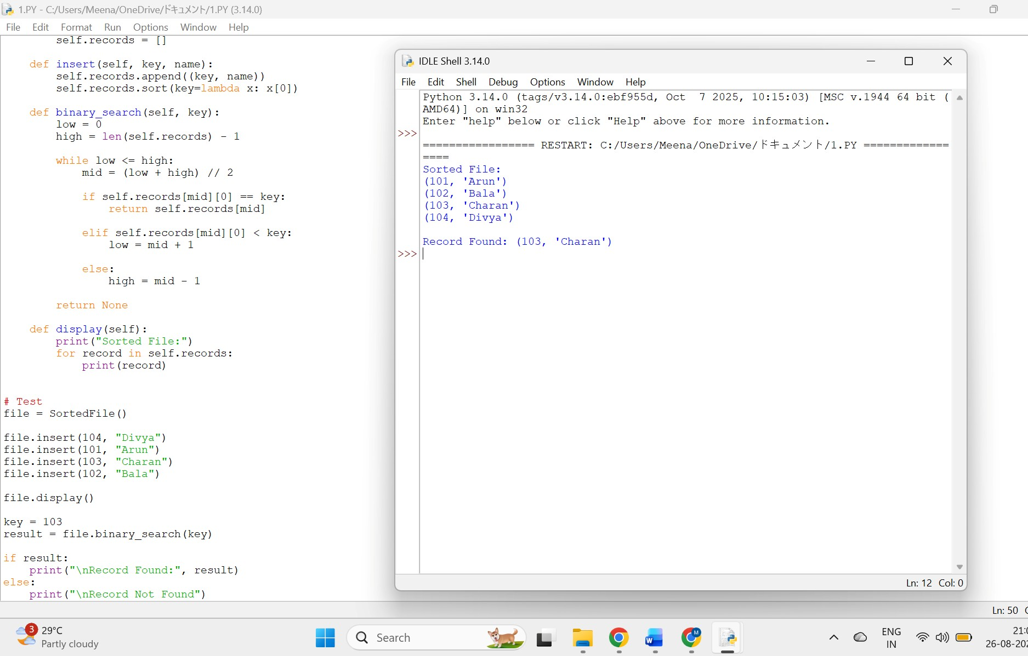

4. Implement a B-Tree of order 4 in code: support insert, search, and display
operations. Insert keys: 10, 20, 5, 6, 12, 30, 7, 17.
For order 4:
- Maximum children = 4
- Maximum keys = 3
Keys:
10, 20, 5, 6, 12, 30, 7, 17 class BTreeNode:
def __init__(self, leaf=False):
self.keys = [] self.children = [] self.leaf = leaf

class BTree: def __init__(self, order=4): self.root = BTreeNode(True) self.max_keys = order - 1

def search(self, node, key): i = 0

while i < len(node.keys) and key > node.keys[i]: i += 1

if i < len(node.keys) and key == node.keys[i]:
return True

if node.leaf: return False return self.search(node.children[i], key)

def split_child(self, parent, index): child = parent.children[index] new_node = BTreeNode(child.leaf)

middle = len(child.keys) // 2 middle_key = child.keys[middle]

new_node.keys = child.keys[middle + 1:] child.keys = child.keys[:middle]

if not child.leaf:
new_node.children = child.children[middle + 1:] child.children = child.children[:middle + 1]

parent.children.insert(index + 1, new_node) parent.keys.insert(index, middle_key)

def insert(self, key): root = self.root

if len(root.keys) == self.max_keys: new_root = BTreeNode(False) new_root.children.append(root) self.root = new_root

self.split_child(new_root, 0) self.insert_non_full(new_root, key) else:
self.insert_non_full(root, key)

def insert_non_full(self, node, key):
i = len(node.keys) - 1
if node.leaf:
node.keys.append(key) node.keys.sort() return

while i >= 0 and key < node.keys[i]:
i -= 1
i += 1

if len(node.children[i].keys) == self.max_keys:
self.split_child(node, i)

if key > node.keys[i]:
i += 1

self.insert_non_full(node.children[i], key)

def display(self, node=None, level=0): if node is None: node = self.root

print("Level", level, ":", node.keys)

if not node.leaf: for child in node.children: self.display(child, level + 1)

# Test btree = BTree(4)

keys = [10, 20, 5, 6, 12, 30, 7, 17] for key in keys:
btree.insert(key)

print("B-Tree:") btree.display()

print("\nSearch 12:", btree.search(btree.root, 12)) print("Search 25:", btree.search(btree.root, 25))
Expected Structure
Level 0 : [10, 20]
Level 1 : [5, 6, 7]
Level 1 : [12, 17]
Level 1 : [30] Complexity:
Insertion: O(log n)
Search: O(log n)
OUTPUT:
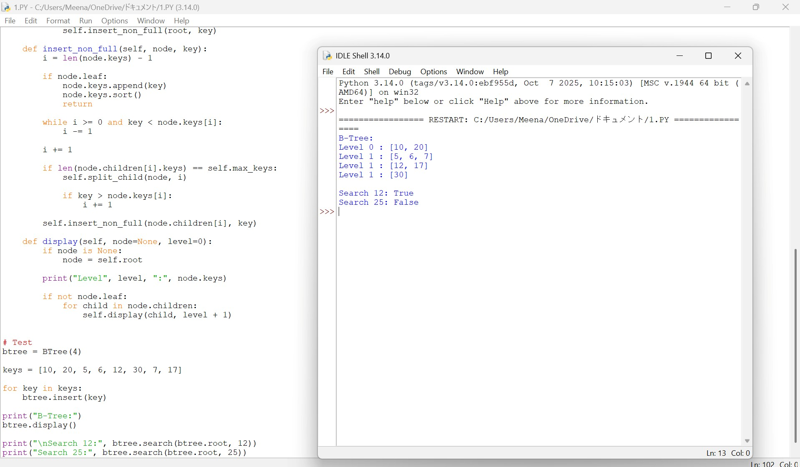
5. Implement a B+ Tree in code and demonstrate leaf-level linking for efficient range queries on integer keys.
The important feature is that leaf nodes are linked sequentially, making range queries efficient.
class BPlusNode:
def __init__(self, leaf=False):
self.leaf = leaf self.keys = [] self.children = [] self.next = None

class BPlusTree: def __init__(self, order=4):
self.order = order self.root = BPlusNode(True)

def find_leaf(self, key):
node = self.root

while not node.leaf: i = 0

while i < len(node.keys) and key >= node.keys[i]: i += 1

node = node.children[i]

return node

def insert(self, key): root = self.root
if root.leaf:
root.keys.append(key) root.keys.sort()

if len(root.keys) >= self.order:
self.split_root()
return

leaf = self.find_leaf(key) leaf.keys.append(key) leaf.keys.sort()

if len(leaf.keys) >= self.order:
self.split_leaf(leaf)

def split_root(self): old_root = self.root

left = BPlusNode(True) right = BPlusNode(True)

mid = len(old_root.keys) // 2

left.keys = old_root.keys[:mid] right.keys = old_root.keys[mid:]

left.next = right

new_root = BPlusNode(False) new_root.keys = [right.keys[0]] new_root.children = [left, right]

self.root = new_root
def split_leaf(self, leaf): right = BPlusNode(True)

mid = len(leaf.keys) // 2

right.keys = leaf.keys[mid:] leaf.keys = leaf.keys[:mid]

right.next = leaf.next leaf.next = right

def range_query(self, low, high): leaf = self.find_leaf(low) result = []

while leaf: for key in leaf.keys: if low <= key <= high: result.append(key)
if key > high: return result

leaf = leaf.next

return result

def display_leaves(self): leaf = self.root

while not leaf.leaf: leaf = leaf.children[0]

print("Leaf-level linked list:") while leaf:
print(leaf.keys, end=" -> ") leaf = leaf.next

print("None")

# Test tree = BPlusTree()

for key in [10, 20, 5, 6, 12, 30, 7, 17, 25, 40]:
tree.insert(key)

tree.display_leaves()

print("Range Query 10-30:") print(tree.range_query(10, 30)) Important advantage:
Leaf 1 -> Leaf 2 -> Leaf 3 -> Leaf 4
The linked leaves allow range queries without repeatedly traversing from the root.

OUTPUT:
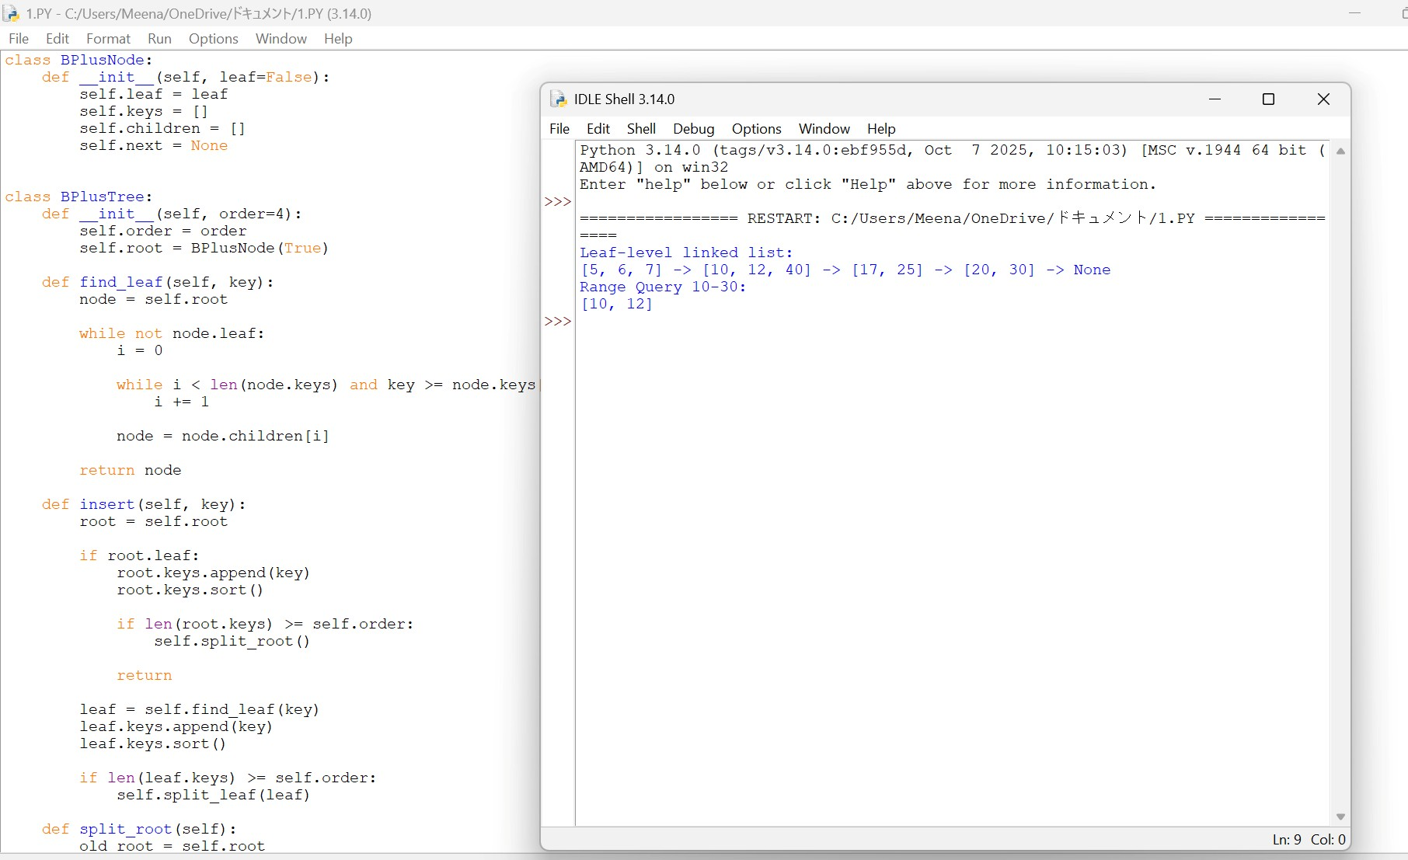

6. Write code to implement a dense primary index on a sorted file. Support search by index key and display the index table.
A dense index contains an index entry for every record.
class DenseIndex: def __init__(self, records): self.records = sorted(records) self.index = [(key, position)
for position, (key, name) in enumerate(self.records)]

def search(self, key):
low = 0
high = len(self.index) - 1

while low <= high:
mid = (low + high) // 2

if self.index[mid][0] == key: position = self.index[mid][1] return self.records[position]

elif self.index[mid][0] < key:
low = mid + 1 else:
high = mid - 1

return None

def display_index(self): print("Dense Index") print("Key\tPointer")

for key, pointer in self.index:
print(key, "\t", pointer)

# Test records = [
(101, "Arun"),
(102, "Bala"),
(103, "Charan"),
(104, "Divya"),
(105, "Ezhil")
]

dense = DenseIndex(records)

dense.display_index()

print("\nSearch 103:") print(dense.search(103))
Dense Index
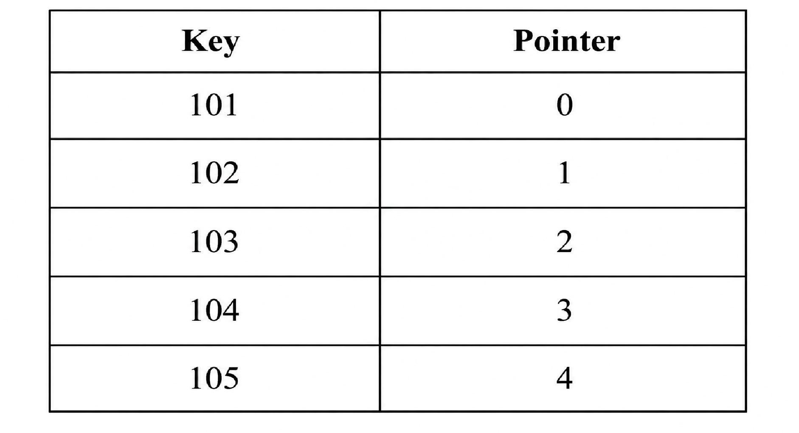
Search complexity: O(log n)
OUTPUT:
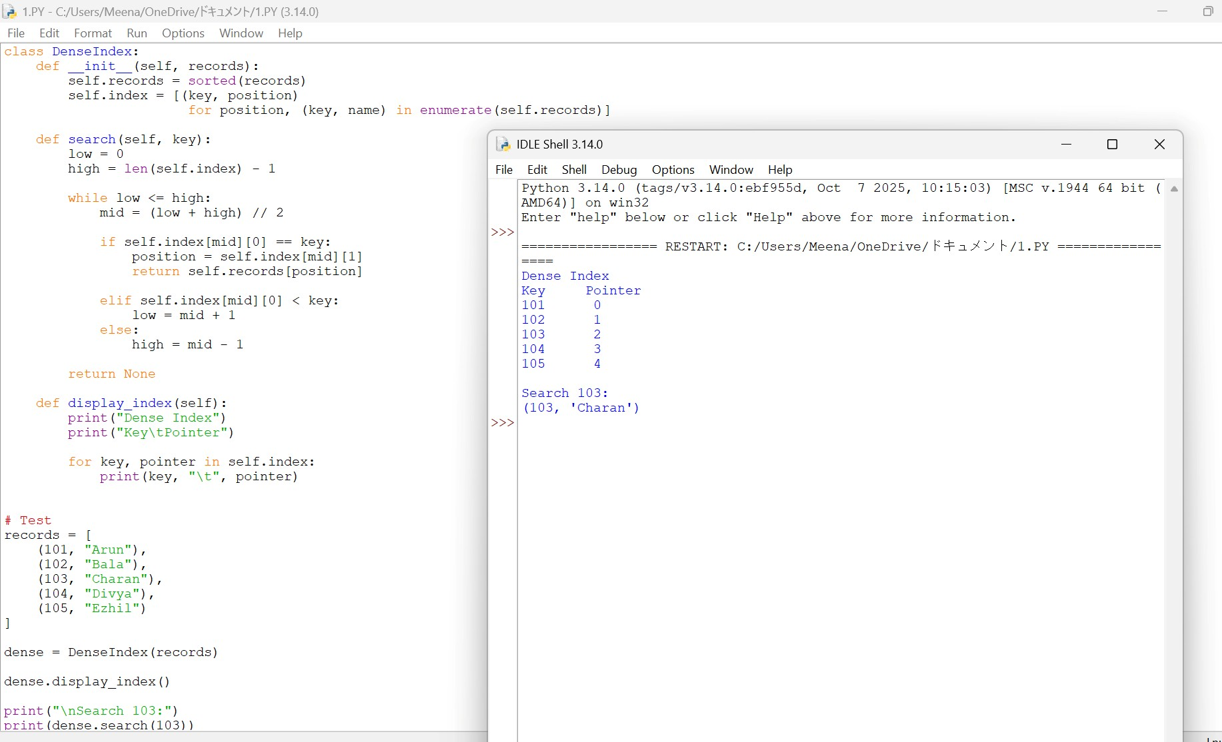

7. Implement extendible hashing in code. Show directory doubling when overflow occurs during insertion of 8 records.
This program demonstrates directory doubling when bucket overflow occurs.
BUCKET_SIZE = 2

class Bucket: def __init__(self, depth):
self.depth = depth self.records = []

class ExtendibleHash: def __init__(self):
self.global_depth = 1

self.directory = [
Bucket(1),
Bucket(1)
]

def hash_value(self, key):
return key & ((1 << self.global_depth) - 1)

def insert(self, key):
index = self.hash_value(key) bucket = self.directory[index]

if key in bucket.records:
return

if len(bucket.records) < BUCKET_SIZE:
bucket.records.append(key) return

self.split_bucket(index) self.insert(key)

def split_bucket(self, index):
old_bucket = self.directory[index]

if old_bucket.depth == self.global_depth:
old_directory = self.directory[:]

self.global_depth += 1

self.directory = old_directory + old_directory[:]

print("\nDirectory doubled.") print("Global Depth =", self.global_depth)

new_depth = old_bucket.depth + 1

new_bucket = Bucket(new_depth) old_bucket.depth = new_depth

pattern = index & ((1 << (new_depth - 1)) - 1)

for i in range(len(self.directory)): if self.directory[i] is old_bucket: if ((i >> (new_depth - 1)) & 1) == 1: self.directory[i] = new_bucket

old_records = old_bucket.records[:] old_bucket.records = []

for record in old_records:
new_index = self.hash_value(record) self.directory[new_index].records.append(record)

def display(self):
print("\nDirectory:") for i, bucket in enumerate(self.directory): print(
format(i, f"0{self.global_depth}b"),
"->", bucket.records, "Local Depth:", bucket.depth
)

# Insert 8 records eh = ExtendibleHash()

for key in [1, 2, 3, 4, 5, 6, 7, 8]:
print("\nInsert:", key) eh.insert(key) eh.display()
Expected Concept
Initial Directory

- -> Bucket
- -> Bucket

↓ Overflow

Directory Doubles

00
01
10 11
The directory grows dynamically rather than using a fixed hash table size.
Complexity:
- Average insertion: O(1)
- Average search: O(1) OUTPUT:
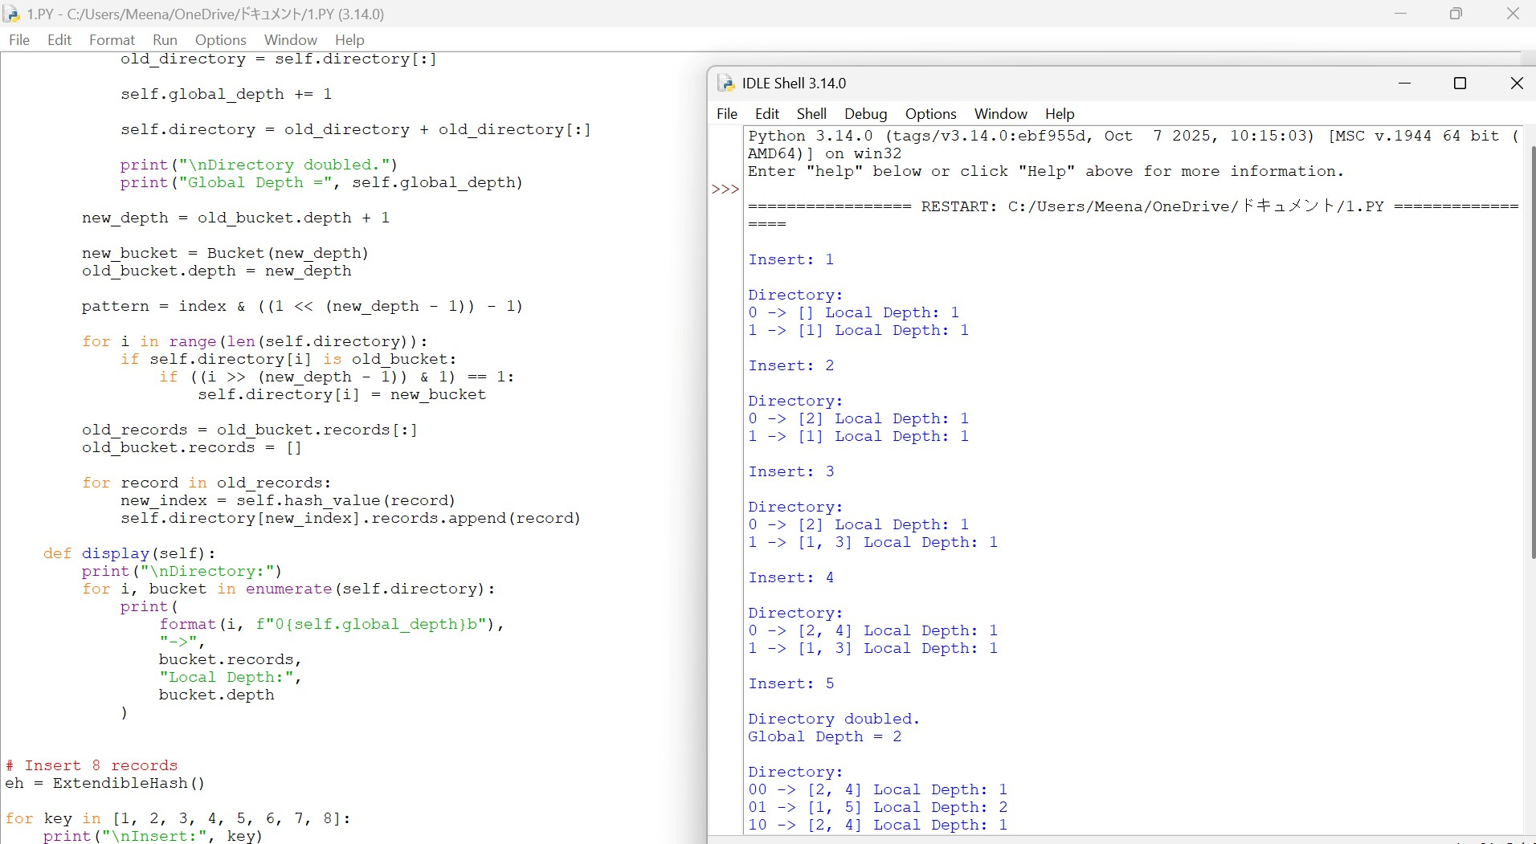
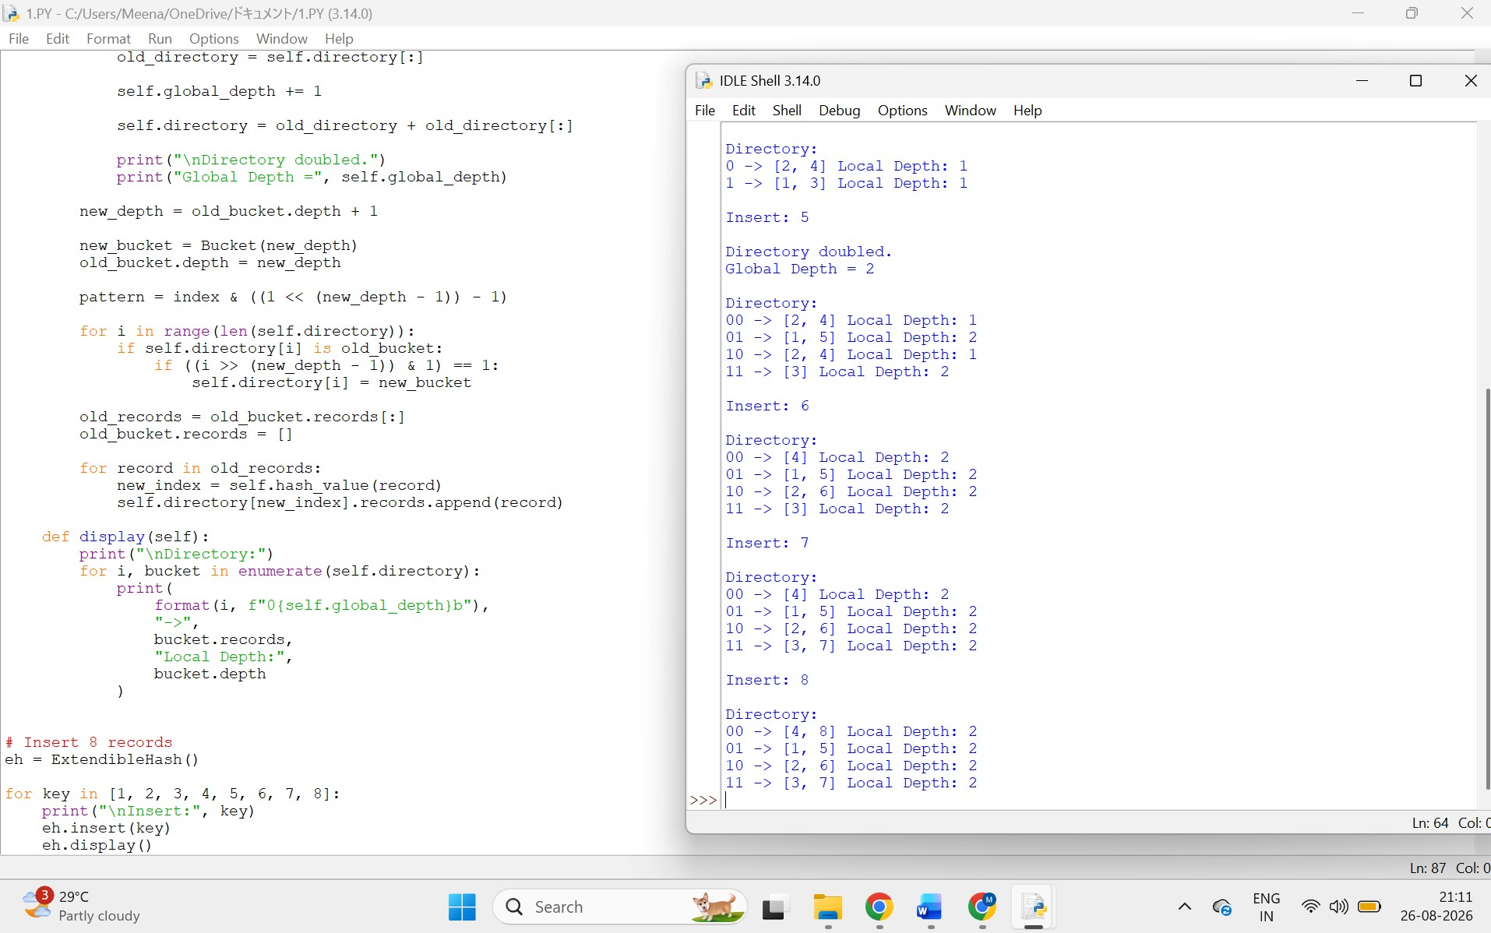

8. Write a program to simulate secondary storage block access. Calculate the number of I/O operations for sequential vs. indexed retrieval.
Assume:
1000 records 10 records per block Therefore:
Number of blocks = 1000 / 10 = 100 import math

def calculate_io(records, records_per_block, retrieval_count):
blocks = math.ceil(records / records_per_block)

sequential_io = blocks

indexed_io = 1 + math.ceil(math.log2(blocks))

print("Total Records:", records)
print("Records per Block:", records_per_block) print("Total Blocks:", blocks)

print("\nSequential Retrieval I/O:", sequential_io)

print("Indexed Retrieval I/O:", indexed_io)

print("\nI/O Reduction:", sequential_io - indexed_io)

calculate_io(1000, 10, 1)

Expected Result
Total Records: 1000
Records per Block: 10
Total Blocks: 100

Sequential Retrieval I/O: 100
Indexed Retrieval I/O: 8

I/O Reduction: 92
Comparison
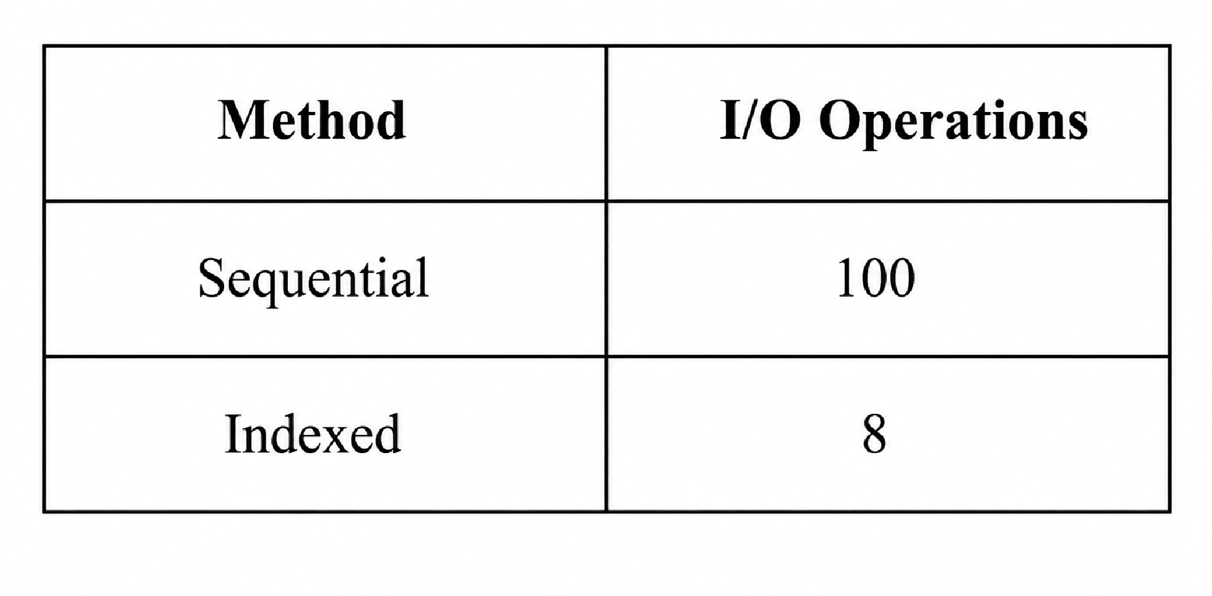
Thus, indexed retrieval significantly reduces secondary-storage I/O.

9. Implement a sparse index on a sorted file in code and compare its search performance with a dense index using timing analysis.
import time import bisect

N = 100000

# Sorted file
records = [(i, "Student" + str(i)) for i in range(N)]

# ---------------- DENSE INDEX ----------------

dense_index = [(key, position)
for position, (key, name) in enumerate(records)]

dense_keys = [x[0] for x in dense_index]

# ---------------- SPARSE INDEX ----------------

BLOCK_SIZE = 100

sparse_index = []

for position in range(0, N, BLOCK_SIZE):
sparse_index.append((records[position][0], position))

sparse_keys = [x[0] for x in sparse_index]

def dense_search(key):
pos = bisect.bisect_left(dense_keys, key)

if pos < len(dense_keys) and dense_keys[pos] == key:
return dense_index[pos][1]

return -1

def sparse_search(key):
pos = bisect.bisect_right(sparse_keys, key) - 1

if pos < 0: pos = 0

start = sparse_index[pos][1] end = min(start + BLOCK_SIZE, N)

for i in range(start, end): if records[i][0] == key:
return i

return -1

# Timing search_key = 98765

start = time.perf_counter()

for _ in range(1000):
dense_search(search_key)

dense_time = time.perf_counter() - start

start = time.perf_counter()

for _ in range(1000):
sparse_search(search_key)

sparse_time = time.perf_counter() - start

print("Dense Index Time :", dense_time) print("Sparse Index Time:", sparse_time)

print("\nDense Search Result:", records[dense_search(search_key)]) print("Sparse Search Result:", records[sparse_search(search_key)])
Complexity
Dense index:
Search = O(log n)
Index size = O(n) Sparse index:
Index size = O(n / block_size)
Search = O(log(n/block_size) + block_size)
The timing values depend on the computer, so the program measures them dynamically rather than using a fixed value.

OUTPUT:
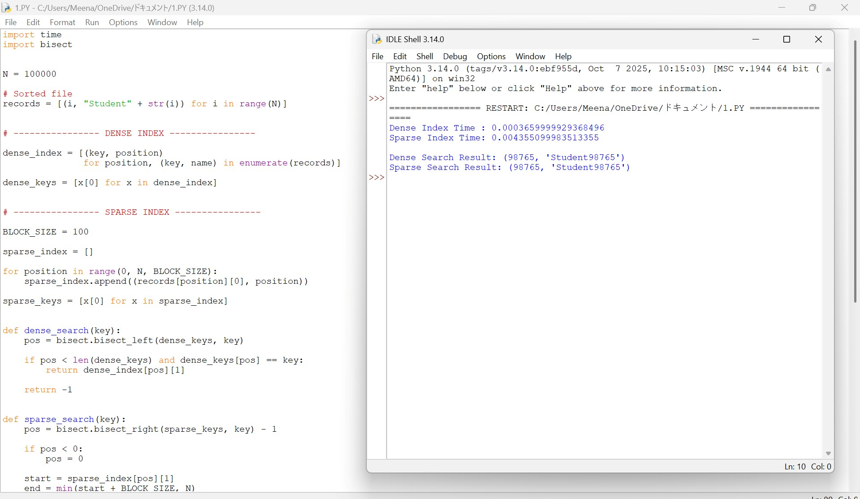

10. Write a program to construct and traverse a B+ Tree, then execute a range query for keys between 15 and 45, showing all matching records.
This program constructs a B+ tree, traverses it, displays the linked leaves, and performs the required range query.
class Node: def __init__(self, leaf=False):
self.leaf = leaf self.keys = [] self.children = [] self.next = None

class BPlusTree: def __init__(self, order=4): self.order = order self.root = Node(True)

def find_leaf(self, key): current = self.root

while not current.leaf: i = 0

while i < len(current.keys) and key >= current.keys[i]: i += 1

current = current.children[i]

return current

def insert(self, key):
leaf = self.find_leaf(key)
leaf.keys.append(key) leaf.keys.sort()

if len(leaf.keys) >= self.order:
self.split_leaf(leaf)

def split_leaf(self, leaf): right = Node(True)

middle = len(leaf.keys) // 2

right.keys = leaf.keys[middle:] leaf.keys = leaf.keys[:middle]

right.next = leaf.next leaf.next = right

# Simplified root handling for demonstration if leaf == self.root:
new_root = Node(False)

new_root.keys = [right.keys[0]] new_root.children = [leaf, right]

self.root = new_root

def traverse(self, node=None, level=0): if node is None: node = self.root

print("Level", level, ":", node.keys)

if not node.leaf: for child in node.children: self.traverse(child, level + 1)

def get_first_leaf(self): node = self.root

while not node.leaf: node = node.children[0]

return node

def range_query(self, low, high): result = []

leaf = self.find_leaf(low)

while leaf:

for key in leaf.keys:
if key > high: return result

if key >= low: result.append(key)

leaf = leaf.next

return result

def display_leaves(self): leaf = self.get_first_leaf()

print("\nLeaf Level:")

while leaf: print(leaf.keys, end=" -> ") leaf = leaf.next

print("None")

# Create B+ Tree bpt = BPlusTree(4)

keys = [
5, 10, 15, 20, 25,
30, 35, 40, 45, 50,
55, 60
]

for key in keys: bpt.insert(key)

print("B+ Tree Traversal:") bpt.traverse()

bpt.display_leaves()

print("\nRange Query: 15 to 45")

result = bpt.range_query(15, 45)

print("Matching Records:", result)
Expected Range Query Output
Range Query: 15 to 45

Matching Records:
[15, 20, 25, 30, 35, 40, 45]
Why B+ Tree is efficient
The search first reaches the appropriate leaf and then follows the leaf-level linked list.
15 → 20 → 25 → 30 → 35 → 40 → 45
This makes range retrieval efficient.
OUTPUT:
